Piako Wine Club
Brennan Winery
This is a boutique winery from Gibbston Valley. They pride themselves on their wines and hospitality, tastings are available with charcuterie boards to accompany them making it all a very enjoyable experience. We are very lucky to have Natalie bring their wines for us to taste.
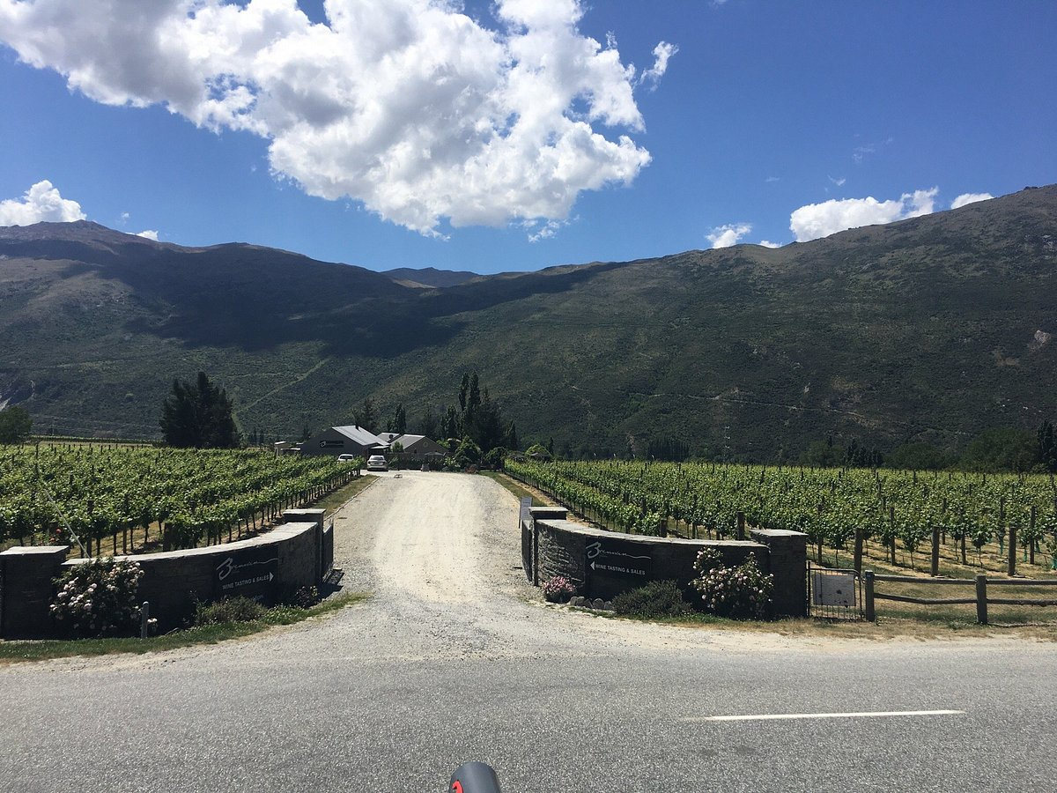
Thursday July 25th at Lyceum Clubrooms at 7.30 pm
Members $15.00, Visitors $20.00
Cost $15 for members and $20 for visitors Acc 03-0371-0103746-000
Replies to Bruce bwsexton@xtra.co.nz 078896018

